Lesson 1 Module 4
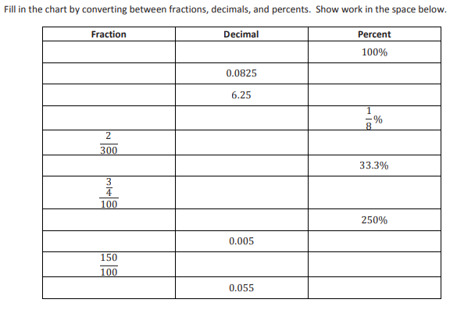
Lesson 1 Module 4

Lesson 2 Module 4
- Represent each situation using an equation. Check your answer with a visual model or numeric method.
- What number is 40% of 90?

- 27 is 30% of what number?

- 21 is what percent of 60?

- 40% of the students on a field trip love the museum. If there are 20 students on the field trip, how many love the museum?

- Maya spent 40% of her savings to pay for a bicycle that cost her $85.
- How much money was in her savings to begin with?
- How much money does she have left in her saving after buying the bicycle?

Lesson 2 Module 4
- Represent each situation using an equation. Check your answer with a visual model or numeric method.

- What number is 40% of 90?

- 27 is 30% of what number?

- 21 is what percent of 60?

- 40% of the students on a field trip love the museum. If there are 20 students on the field trip, how many love the museum?

- Maya spent 40% of her savings to pay for a bicycle that cost her $85.
- How much money was in her savings to begin with?
- How much money does she have left in her saving after buying the bicycle?

Lesson 3 Module 4
Solve each problem using an equation.
- 49.5 is what percent of 33?

- 72 is what percent of 180?

- What percent of 80 is 90?

Lesson 3 Module 4
Solve each problem using an equation.
- 49.5 is what percent of 33?

- 72 is what percent of 180?

- What percent of 80 is 90?

Lesson 4 Module 4
- A store advertises 15% off an item that regularly sells for $300
- What is the sale price for the item?

- If 8% sales tax is charged on the sale price, what is the total with tax?

- An item that was selling 72 is reduced to 60. Find the recent decrease in price. Round your answer to the nearest tenth.

- A baseball team had 80 players show up for tryouts last year and this year had 96 players show up for tryouts. Find the percent increase in players from last year to this year?

Lesson 4 Module 4
- A store advertises 15% off an item that regularly sells for $300
- What is the sale price for the item?

- If 8% sales tax is charged on the sale price, what is the total with tax?

- An item that was selling 72 is reduced to 60. Find the recent decrease in price. Round your answer to the nearest tenth.

- A baseball team had 80 players show up for tryouts last year and this year had 96 players show up for tryouts. Find the percent increase in players from last year to this year?

Lesson 5 Module 4
Use a double number line to answer Problems 1–5.
- Tanner collected 360 cans and bottles while fundraising for his baseball team. This was 40% of what Reggie collected. How many cans and bottles did Reggie collect?

- Emilio paid $287.50 in taxes to the school district that he lives in this year. This year’s taxes were a 15% increase from last year. What did Emilio pay in school taxes last year?

- A snowmobile manufacturer claims that its newest model is 15% lighter than last year’s model. If this year’s model weighs 799 lb., how much did last year’s model weigh?

- Student enrollment at a local school is concerning the community because the number of students has dropped to 504, which is a 20% decrease from the previous year. What was the student enrollment the previous year?

- The color of paint used to paint a race car includes a mixture of yellow and green paint. Scotty wants to lighten the color by increasing the amount of yellow paint 30%. If a new mixture contains 3.9 liters of yellow paint, how many liters of yellow paint did he use in the previous mixture?

Lesson 6 Module 4
- Micah has 294 songs stores in his phone, which is 70% of the songs that Jorge has stored in his phone. How many songs are stored on Jorge’s phone?

- Lisa sold 81 magazines subscriptions, which is 27% of her class’s fundraising goal. How many magazine subscriptions does her class hope to sell?

- In a parking garage, the number of SUV’s is 40% greater than the number of non-SUVs. Gina counted 98 SUVs in the parking garage. How many vehicles were parked in the garage?

- The price of a tent was decrease by 15% and sold for $76.49. what was the original price of the tent in dollars?

Lesson 6 Module 4
- Micah has 294 songs stores in his phone, which is 70% of the songs that Jorge has stored in his phone. How many songs are stored on Jorge’s phone?

- Lisa sold 81 magazines subscriptions, which is 27% of her class’s fundraising goal. How many magazine subscriptions does her class hope to sell?

- In a parking garage, the number of SUV’s is 40% greater than the number of non-SUVs. Gina counted 98 SUVs in the parking garage. How many vehicles were parked in the garage?

- The price of a tent was decrease by 15% and sold for $76.49. what was the original price of the tent in dollars?

Lesson 7 Module 4
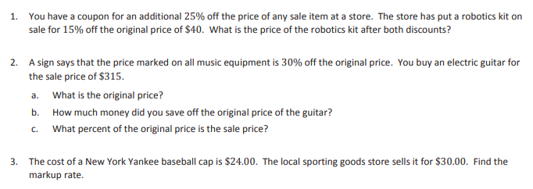

Lesson 7 Module 4

Lessons 8 Module 4
- The odometer in Mr. Washington’s car does not work correctly. The odometer recorded 13.2 miles for his last trip to the hardware store, but he knows the distance traveled is 15 miles. What is the percent error?

- Kayla’s Class went on a field trip to the aquarium. One tank had 30 clown fish. She miscounted the total number of clown fish in the tank and recorded it as 24 fish. What is Kayla’s percent error?

- Sid did geometry software to draw a circle of a radius of 4 units on the grid. He estimated the area of the circle by counting the squares that were mostly inside the circle and got an answer of 52 square units.
- Is his estimate too large or too small?
- Find the percent error in Sid’s estimation to nearest hundredth.

Lesson 8 Module 4
- The odometer in Mr. Washington’s car does not work correctly. The odometer recorded 13.2 miles for his last trip to the hardware store, but he knows the distance traveled is 15 miles. What is the percent error?

- Kayla’s Class went on a field trip to the aquarium. One tank had 30 clown fish. She miscounted the total number of clown fish in the tank and recorded it as 24 fish. What is Kayla’s percent error?

- Sid did geometry software to draw a circle of a radius of 4 units on the grid. He estimated the area of the circle by counting the squares that were mostly inside the circle and got an answer of 52 square units.
- Is his estimate too large or too small?
- Find the percent error in Sid’s estimation to nearest hundredth.
Lesson 9 Module 4
1. Solve each problem using an equation.
a. What is 150% of 625?
b. 90 is 40% of what number?
c. What percent of 520 is 40? Round to the nearest hundredth of a percent.
2. The actual length of a machine is 12.25 cm. The measured length is 12.2 cm. Round the answer to part (b) to the nearest hundredth of a percent.
a. Find the absolute error.
b. Find the percent error.
3. A rowing club has 600 members. 60% of them are women. After 200 new members joined the club, the percentage of women was reduced to 50%. How many of the new members are women?

Lesson 9 Module 4
1. Solve each problem using an equation.
a. What is 150% of 625?
b. 90 is 40% of what number?
c. What percent of 520 is 40? Round to the nearest hundredth of a percent.
2. The actual length of a machine is 12.25 cm. The measured length is 12.2 cm. Round the answer to part (b) to the nearest hundredth of a percent.
a. Find the absolute error.
b. Find the percent error.
3. A rowing club has 600 members. 60% of them are women. After 200 new members joined the club, the percentage of women was reduced to 50%. How many of the new members are women?

Lesson 10 Module 4
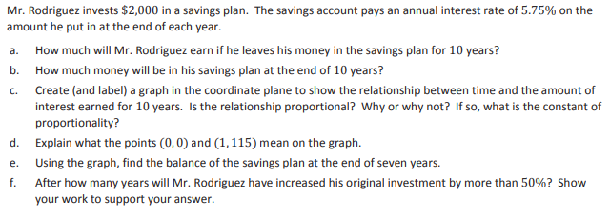

Lesson 11 Module 4
1. A school district’s property tax rate rises from 2.5% to 2.7% to cover a $300,000 budget deficit (shortage of money). What is the value of the property in the school district to the nearest dollar? (Note: Property is assessed at 100% of its value.)
2. Jake’s older brother Sam has a choice of two summer jobs. He can either work at an electronics store or at the school’s bus garage. The electronics store would pay him to work 15 hours per week. He would make $8 per hour plus a 2% commission on his electronics sales. At the school’s bus garage, Sam could earn $300 per week working 15 hours cleaning buses. Sam wants to take the job that pays him the most. How much in electronics would Sam have to sell for the job at the electronics store to be the better choice for his summer job?
3. Sarah lost her science book. Her school charges a lost book fee equal to 75% of the cost of the book. Sarah received a notice stating she owed the school $60 for the lost book.
a. Write an equation to represent the proportional relationship between the school’s cost for the book and the amount a student must pay for a lost book. Let 𝐵 represent the school’s cost of the book in dollars and 𝑁represent the student’s cost in dollars.
b. What is the constant or proportionality? What does it mean in the context of this situation?
c. How much did the school pay for the book?

Lesson 11 Module 4
1. A school district’s property tax rate rises from 2.5% to 2.7% to cover a $300,000 budget deficit (shortage of money). What is the value of the property in the school district to the nearest dollar? (Note: Property is assessed at 100% of its value.)
2. Jake’s older brother Sam has a choice of two summer jobs. He can either work at an electronics store or at the school’s bus garage. The electronics store would pay him to work 15 hours per week. He would make $8 per hour plus a 2% commission on his electronics sales. At the school’s bus garage, Sam could earn $300 per week working 15 hours cleaning buses. Sam wants to take the job that pays him the most. How much in electronics would Sam have to sell for the job at the electronics store to be the better choice for his summer job?
3. Sarah lost her science book. Her school charges a lost book fee equal to 75% of the cost of the book. Sarah received a notice stating she owed the school $60 for the lost book.
a. Write an equation to represent the proportional relationship between the school’s cost for the book and the amount a student must pay for a lost book. Let 𝐵 represent the school’s cost of the book in dollars and 𝑁represent the student’s cost in dollars.
b. What is the constant or proportionality? What does it mean in the context of this situation?
c. How much did the school pay for the book?

Lesson 12 Module 4
- A 5-liter cleaning solution contains 30% bleach. A 3-liter solution contains 50% bleach. What percent of bleach is obtained by putting the two mixtures together?

- A container is filled with 100 grams of bird feed that is 80% seed. How many grams of bird feed containing 5% seed must be added to get bird feed that is 40%?

- Anna wants to make 30 mL of a 60% salt solution by mixing together a 72% salt solution and a 54% salt solution. How much of each solution must she use?

Lesson 12 Module 4
- A 5-liter cleaning solution contains 30% bleach. A 3-liter solution contains 50% bleach. What percent of bleach is obtained by putting the two mixtures together?

- A container is filled with 100 grams of bird feed that is 80% seed. How many grams of bird feed containing 5% seed must be added to get bird feed that is 40%?

- Anna wants to make 30 mL of a 60% salt solution by mixing together a 72% salt solution and a 54% salt solution. How much of each solution must she use?

Lesson 13 Module 4

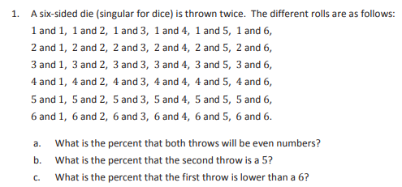

Lesson 13 Module 4

Lesson 14 Module 4
For #s 2,3,4,5 and 7 also explain the likelihood of the event
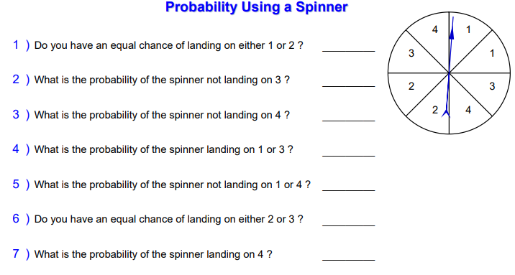
Lesson 14 Module 4
For #s 2,3,4,5 and 7 also explain the likelihood of the event

Lesson 15 Module 4
Work on a separate sheet of paper
- The following data represent the number of pop-up advertisements received by 10 families during the past month. Calculate the averages of advertisements received by each family during the month. 43 37 35 30 41 23 33 31 16 21

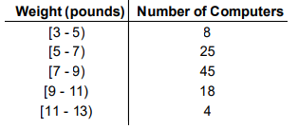
- The following table of grouped data represents the weight (in pounds) of 100 computer towers. Calculate the mean weight for a computer.

- The temperature in o F (degrees Fahrenheit) on 20 days during the month of June was as follows: (find the averages)

70 o F, 76o F, 76 o F, 74o F, 70o F, 70 o F, 72o F, 74 o F, 78o F, 80o F, 74 o F, 74o F, 78 o F, 76o F, 78o F, 76 o F, 74o F, 78 o F, 80o F, 76o F

Lesson 15 Module 4
Work on a separate sheet of paper
- The following data represent the number of pop-up advertisements received by 10 families during the past month. Calculate the averages of advertisements received by each family during the month. 43 37 35 30 41 23 33 31 16 21

- The following table of grouped data represents the weight (in pounds) of 100 computer towers. Calculate the mean weight for a computer.

- The temperature in o F (degrees Fahrenheit) on 20 days during the month of June was as follows: (find the averages)

70 o F, 76o F, 76 o F, 74o F, 70o F, 70 o F, 72o F, 74 o F, 78o F, 80o F, 74 o F, 74o F, 78 o F, 76o F, 78o F, 76 o F, 74o F, 78 o F, 80o F, 76o F

Lesson 16 Module 4
- 3 people win $120 in the lottery. They split it in the ratio 1:3:8. How much does each person get?

- Jon and Bon invest $3400 in their local bank. They put the money in in ratio 3:7.

a) How much did each person put in?
b) After a year, the money accrues interest. They withdraw $6200 and split the new amount in the same ratio. How much do they both now get?

- An estate is shared between Tom, Thom and Thomas in the ratio 2:3:5. If Tom received $2400. How much did the others get?

Lesson 16 Module 4
- 3 people win $120 in the lottery. They split it in the ratio 1:3:8. How much does each person get?

- Jon and Bon invest $3400 in their local bank. They put the money in in ratio 3:7.

a) How much did each person put in?
b) After a year, the money accrues interest. They withdraw $6200 and split the new amount in the same ratio. How much do they both now get?

6) An estate is shared between Tom, Thom and Thomas in the ratio 2:3:5. If Tom received $2400. How much did the others get?

Lesson 17 Module 4
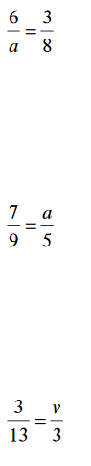
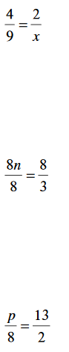

Lesson 17 Module 4

Lesson 18 Module 5
