Module 3 Lesson 1 Homework
For Problems 1–9, write equivalent expressions by combining like terms. Verify the equivalence of your expression and the given expression by evaluating each for the given values: 𝑎 = 2, 𝑏 = 5, and 𝑐 =– 3.
1. 3𝑎 + 5𝑎
2. 8𝑏 − 4𝑏
3. 5𝑐 + 4𝑐 + 𝑐
4. 3𝑎 + 6 + 5𝑎
5. 8𝑏 + 8 − 4𝑏
6. 5𝑐 − 4𝑐 + 𝑐
7. 3𝑎 + 6 + 5𝑎 – 2
8. 8𝑏 + 8 − 4𝑏 − 3
9. 5𝑐 − 4𝑐 + 𝑐 – 3 𝑐

Module 3 Lesson 1 Homework
For Problems 1–9, write equivalent expressions by combining like terms. Verify the equivalence of your expression and the given expression by evaluating each for the given values: 𝑎 = 2, 𝑏 = 5, and 𝑐 =– 3.
1. 3𝑎 + 5𝑎
2. 8𝑏 − 4𝑏
3. 5𝑐 + 4𝑐 + 𝑐
4. 3𝑎 + 6 + 5𝑎
5. 8𝑏 + 8 − 4𝑏
6. 5𝑐 − 4𝑐 + 𝑐
7. 3𝑎 + 6 + 5𝑎 – 2
8. 8𝑏 + 8 − 4𝑏 − 3
9. 5𝑐 − 4𝑐 + 𝑐 – 3 𝑐

Module 3 Lesson 2 Homework
Show work in a separate paper
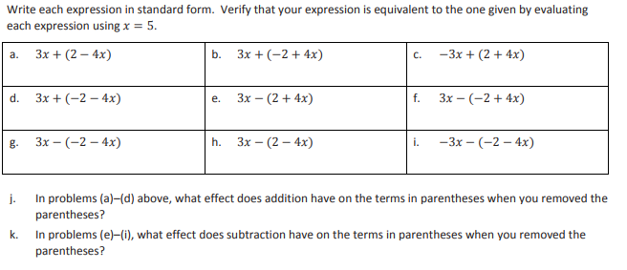

Module 3 Lesson 2 Homework
Show work in a separate paper

Module 3 Lessons 3 Homework
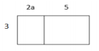
- a. Write two equivalent expressions that represent the rectangular array below.

b. Verify informally that the two expressions are equivalent using substitution.

- Use a rectangular array to write the products in standard form.
a. 2(𝑥 + 10)
b. 3(4𝑏 + 12𝑐 + 11)

- Use the distributive property to write the products in standard form.
a. 3(2𝑥 − 1) b. 10(𝑏 + 4𝑐) c. 7(4𝑛 − 5𝑚 − 2)

d. 𝑎 (𝑏 + 𝑐 + 1) e. (40𝑠 + 100𝑡) ÷ 10 f. (48𝑝 + 24) ÷ 6

Module 3 Lessons 3 Homework
- a. Write two equivalent expressions that represent the rectangular array below.

b. Verify informally that the two expressions are equivalent using substitution.

- Use a rectangular array to write the products in standard form.
a. 2(𝑥 + 10)
b. 3(4𝑏 + 12𝑐 + 11)

- Use the distributive property to write the products in standard form.
a. 3(2𝑥 − 1) b. 10(𝑏 + 4𝑐) c. 7(4𝑛 − 5𝑚 − 2)

d. 𝑎 (𝑏 + 𝑐 + 1) e. (40𝑠 + 100𝑡) ÷ 10 f. (48𝑝 + 24) ÷ 6

Module 3 Lesson 4 Homework
- Write each expression as a product of two factors:
a. 1 ∙ 3 + 7 ∙ 3 b. (1 + 7) + (1 + 7) + (1 + 7) c. 2 ∙ 1 + (1 + 7) + (7 ∙ 2)

d. ℎ ∙ 3 + 6 ∙ 3 e. 6 ∙ 7 + 3 ∙ 7 f. (8 + 9) + (8 + 9) + (8 + 9)

g. 4 + (12 + 4) + (5 ∙ 4) h. 2𝑦 ∙ 3 + 4 ∙ 3

- Use the following rectangular array to answer the question below
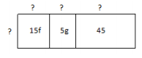
- Fill in the missing information.

b. Write the sum represented in the rectangular array.

Module 3 Lesson 4 Homework
- Write each expression as a product of two factors:
a. 1 ∙ 3 + 7 ∙ 3 b. (1 + 7) + (1 + 7) + (1 + 7) c. 2 ∙ 1 + (1 + 7) + (7 ∙ 2)

d. ℎ ∙ 3 + 6 ∙ 3 e. 6 ∙ 7 + 3 ∙ 7 f. (8 + 9) + (8 + 9) + (8 + 9)

g. 4 + (12 + 4) + (5 ∙ 4) h. 2𝑦 ∙ 3 + 4 ∙ 3

- Use the following rectangular array to answer the question below
- Fill in the missing information.

b. Write the sum represented in the rectangular array.

Module 3 Lesson 5 Homework
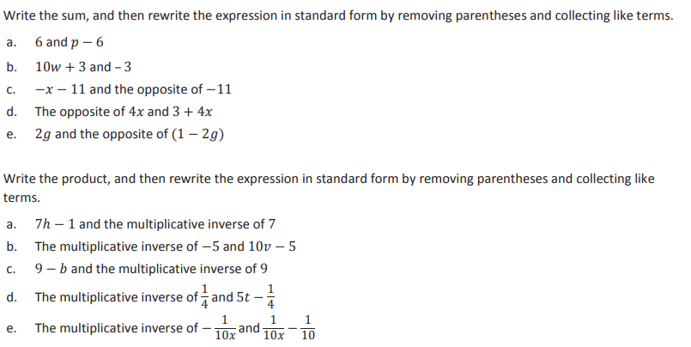

Module 3 Lesson 5 Homework

Module 3 Lesson 6 Homework
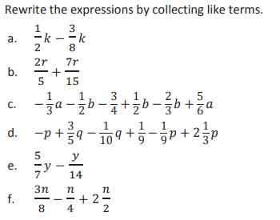

Module 3 Lesson 6 Homework

Module 3 Lesson 7 Homework
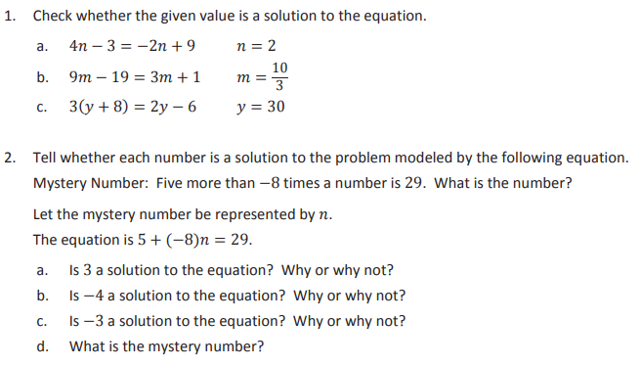

Module 3 Lesson 7 Homework

Module 3 Lesson 8 Homework
Write and solve an equation for each problem
- 1. The perimeter of a rectangle is 30 inches. If its length is three times its width, find the dimensions.

- 2. A cell phone company has a basic monthly plan of $40 plus $0.45 for any minutes used over 700. Before receiving his statement, John saw he was charged a total of $48.10. Write and solve an equation to determine how many minutes he must have used during the month.

- Barry’s mountain bike weighs 6 pounds more than Andy’s. If their bikes weigh 42 pounds altogether, how much does Barry’s bike weigh?

- Trevor and Marissa together have 26 T-shirts to sell. If Marissa has 6 fewer T-shirts than Trevor, find how many T-shirts Trevor has.

Module 3 Lesson 8 Homework
Write and solve an equation for each problem
- 1. The perimeter of a rectangle is 30 inches. If its length is three times its width, find the dimensions.

- 2. A cell phone company has a basic monthly plan of $40 plus $0.45 for any minutes used over 700. Before receiving his statement, John saw he was charged a total of $48.10. Write and solve an equation to determine how many minutes he must have used during the month.

- Barry’s mountain bike weighs 6 pounds more than Andy’s. If their bikes weigh 42 pounds altogether, how much does Barry’s bike weigh?

- Trevor and Marissa together have 26 T-shirts to sell. If Marissa has 6 fewer T-shirts than Trevor, find how many T-shirts Trevor has.

Module 3 Lesson 9 Homework
- Caitlan went to the store to buy school clothes. She had a store credit from a previous return in the amount of $39.58. If she bought 4 of the same style shirt in different colors and spent a total of $52.22 after the store credit was taken off her total, what was the price of each shirt she bought? Write and solve an equation with integer coefficients.

- A young boy is growing at a rate of 3.5 cm per month. He is currently 90 cm tall. At that rate, in how many months will the boy grow to a height of 132 cm?

- The sum of a number, $\frac{1}{6}$ of that number, $2\frac{1}{2}$ of that number, and 7 is$12\frac{1}{2}$. Find the number.

- Paulie ordered 250 pens and 250 pencils to sell for a theatre club fundraiser. The pens cost 11 cents more than the pencils. If Paulie’s total order costs $42.50, find the cost of each pen and pencil.

Module 3 Lesson 9 Homework

- Caitlan went to the store to buy school clothes. She had a store credit from a previous return in the amount of $39.58. If she bought 4 of the same style shirt in different colors and spent a total of $52.22 after the store credit was taken off her total, what was the price of each shirt she bought? Write and solve an equation with integer coefficients.

- A young boy is growing at a rate of 3.5 cm per month. He is currently 90 cm tall. At that rate, in how many months will the boy grow to a height of 132 cm?

- The sum of a number, $\frac{1}{6}$ of that number, $2\frac{1}{2}$ of that number, and 7 is$12\frac{1}{2}$. Find the number.

- Paulie ordered 250 pens and 250 pencils to sell for a theatre club fundraiser. The pens cost 11 cents more than the pencils. If Paulie’s total order costs $42.50, find the cost of each pen and pencil.

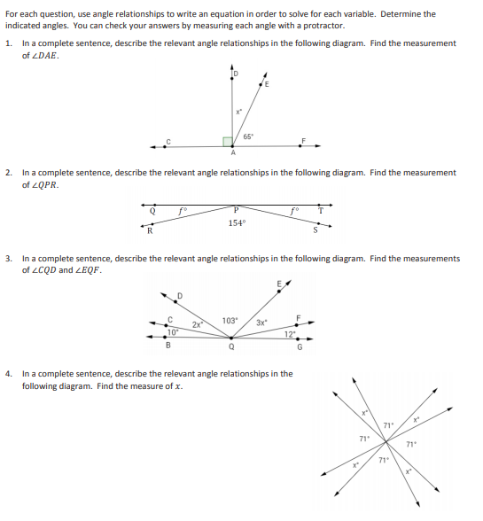
Module 3 Lesson 10 Homework

Module 3 Lesson 11 Homework

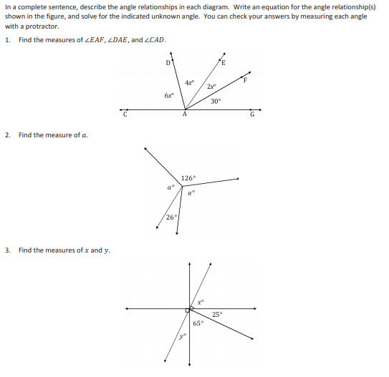

Module 3 Lesson 12 Homework
- For each problem, use the properties of inequalities to write a true inequality statement.
The two integers are −2 and −5.
- Write a true inequality statement

- Subtract −2 from each side of the inequality. Write a true inequality statement.

- Multiply each number by −3. Write a true inequality statement.

- On a recent vacation to the Caribbean, Kay and Tony wanted to explore the ocean elements. One day they went in a submarine 150 feet below sea level. The second day they went scuba diving 75 feet below sea level.
- Write an inequality comparing the submarine’s elevation and the scuba diving elevation.
- If they only were able to go one-fifth of the capable elevations, write a new inequality to show the elevations they actually achieved
- Was the inequality symbol preserved or reversed? Explain.
Module 3 Lesson 12 Homework
- For each problem, use the properties of inequalities to write a true inequality statement.
The two integers are −2 and −5.
- Write a true inequality statement

- Subtract −2 from each side of the inequality. Write a true inequality statement.

- Multiply each number by −3. Write a true inequality statement.

- On a recent vacation to the Caribbean, Kay and Tony wanted to explore the ocean elements. One day they went in a submarine 150 feet below sea level. The second day they went scuba diving 75 feet below sea level.
- Write an inequality comparing the submarine’s elevation and the scuba diving elevation.
b. If they only were able to go one-fifth of the capable elevations, write a new inequality to show the elevations they actually achieved.
c. Was the inequality symbol preserved or reversed? Explain.

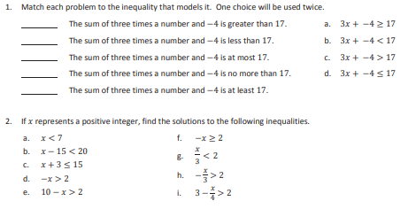
Module 3 Lesson 13 Homework
*May have no solutions

Module 3 Lesson 13 Homework
*May have no solutions

Module 3 Lesson 14 Homework
- Traci collects donations for a dance marathon. One group of sponsors will donate a total of $6 for each hour she dances. Another group of sponsors will donate $75 no matter how long she dances. What number of hours, to the nearest hour, should Traci dance if she wants to raise at least $1,000?

- Jack’s age is three years more than twice the age of his younger brother, Jimmy. If the sum of their ages is at most 18, find the greatest age that Jimmy could be.

- Brenda has $500 in her bank account. Every week she withdraws $40 for miscellaneous expenses. How many weeks can she withdraw the money if she wants to maintain a balance of a least $200?

Module 3 Lesson 14 Homework
- Traci collects donations for a dance marathon. One group of sponsors will donate a total of $6 for each hour she dances. Another group of sponsors will donate $75 no matter how long she dances. What number of hours, to the nearest hour, should Traci dance if she wants to raise at least $1,000?

- Jack’s age is three years more than twice the age of his younger brother, Jimmy. If the sum of their ages is at most 18, find the greatest age that Jimmy could be.

- Brenda has $500 in her bank account. Every week she withdraws $40 for miscellaneous expenses. How many weeks can she withdraw the money if she wants to maintain a balance of a least $200?
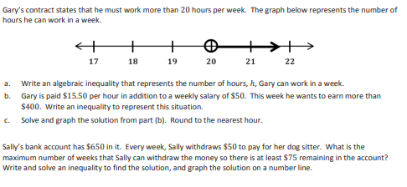
Module 3 Lesson 15 Homework

Module 3 Lesson 15 Homework
Module 3 Lesson 16 Homework
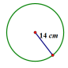
1. Find the circumference.
a. Give an exact answer in terms of 𝜋.
b. Use 𝜋 ≈ 22/ 7 and express your answer as a fraction in lowest terms.

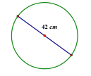
2. Find the circumference.
a. Give an exact answer in terms of 𝜋.
b. Use 𝜋 ≈ 22 /7 , and express your answer as a fraction in lowest terms.

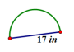
3.Find the perimeter of the semicircle. Let 𝜋 ≈ 3.14.

Module 3 Lesson 16 Homework
1. Find the circumference.
a. Give an exact answer in terms of 𝜋.
b. Use 𝜋 ≈ 22/ 7 and express your answer as a fraction in lowest terms.

2. Find the circumference.
a. Give an exact answer in terms of 𝜋.
b. Use 𝜋𝜋 ≈ 22 /7 , and express your answer as a fraction in lowest terms.

3. Find the perimeter of the semicircle. Let 𝜋 ≈ 3.14.

Module 3 Lesson 17 Homework
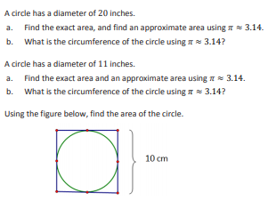
Module 3 Lesson 17 Homework

Module 3 Lesson 18 Homework
Work on a separate paper
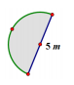
- Mark created a flower bed that is semicircular in shape, as shown in the image. The diameter of the flower bed is 5 m
a. What is the perimeter of the flower bed? (Approximate 𝜋 to be 3.14.)
b. What is the area of the flower bed? (Approximate 𝜋 to be 3.14.)

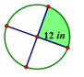
- Find the area of the shaded region. (Approximate 𝜋𝜋 to be 22/7 .)

- The figure below shows a circle inside of a square. If the radius of the circle is 8 cm, find the following and explain your solution.
a. The circumference of the circle
b. The area of the circle
c. The area of the square

Module 3 Lesson 18 Homework
Work on a separate paper
- Mark created a flower bed that is semicircular in shape, as shown in the image. The diameter of the flower bed is 5 m
a. What is the perimeter of the flower bed? (Approximate 𝜋 to be 3.14.)
b. What is the area of the flower bed? (Approximate 𝜋 to be 3.14.)

- Find the area of the shaded region. (Approximate 𝜋𝜋 to be 22/7 .)

- The figure below shows a circle inside of a square. If the radius of the circle is 8 cm, find the following and explain your solution.
a. The circumference of the circle
b. The area of the circle
c. The area of the square

Module3 Lesson 19 Homework (find area)
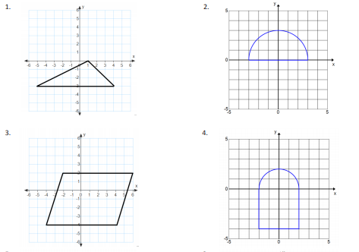
Module 3 Lesson 19 Homework (find area)

Module 3 Lesson 20 Homework

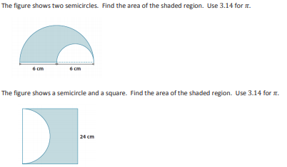

Module 3 Lesson 20 Homework

