Module 2 Lesson 1 Homework
- You have two cards with the sum of (-12) in your hand.
- What two cards could you have?

- You add two more cards to your hand, but the total sum of the cards remain the same (-12). Give some different examples of two cards you could choose.

- On the number line below, the number h and k are the same distance from 0. Write an equation to express the value h+k. Explain.
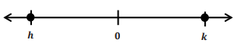

- During a football game, Kevin gained 5 yards on the first play. Then he lost seven yards on the second play. How many yards does Kevin need on the next play to get the team back to where they were when they started? Show your work.

Module 2 Lesson 1 Homework
- You have two cards with the sum of (-12) in your hand.
- What two cards could you have?

- You add two more cards to your hand, but the total sum of the cards remain the same (-12). Give some different examples of two cards you could choose.

- On the number line below, the number h and k are the same distance from 0. Write an equation to express the value h+k. Explain.

- During a football game, Kevin gained 5 yards on the first play. Then he lost seven yards on the second play. How many yards does Kevin need on the next play to get the team back to where they were when they started? Show your work.

Module 2 Lesson 2 Homework
1) In the Integer Card Game, you drew the cards, 2, 8, and −11. Your partner gave you a 7 from his hand.
a. What is your total? Model your answer on the number line below.

b. What card(s) would you need to get your score back to zero? Explain. Use and explain the term additive inverse in your answer.

2) If a football player gains 40 yards on a play, but on the next play, he loses 10 yards, what would his total yards be for the game if he ran for another 60 yards? What did you count by to label the units on your number line?

Module 2 Lesson 2 Homework
1) In the Integer Card Game, you drew the cards, 2, 8, and −11. Your partner gave you a 7 from his hand.
a. What is your total? Model your answer on the number line below.

b. What card(s) would you need to get your score back to zero? Explain. Use and explain the term additive inverse in your answer.

2) If a football player gains 40 yards on a play, but on the next play, he loses 10 yards, what would his total yards be for the game if he ran for another 60 yards? What did you count by to label the units on your number line?

Module 2 Lesson 3 Homework
Below is a table showing the change in temperature from morning to afternoon for one week.
a. Use the vertical number line to help you complete the table. As an example, the first row is completed for you.
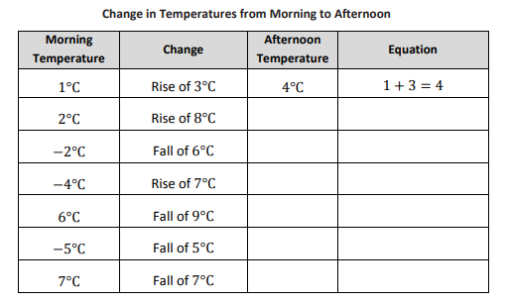b. Do you agree or disagree with the following statement: A rise of -7 degrees means a “fall of 7 degrees”. Explain.
Module 2 Lesson 3 Homework
Below is a table showing the change in temperature from morning to afternoon for one week.
a. Use the vertical number line to help you complete the table. As an example, the first row is completed for you.
b. Do you agree or disagree with the following statement: A rise of -7 degrees means a “fall of 7 degrees”. Explain.
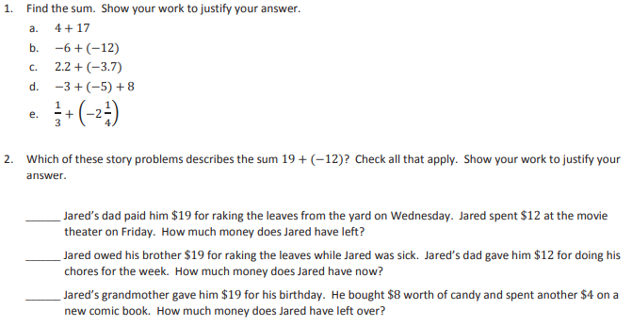Module 2 Lesson 4 Homework

Module 2 Lesson 4 Homework
Module 2 Lesson 5 Homework
Write the following expressions as a single integer.
a. −2 + 16
b. −2 − (−16)
c. 18 − 26
d. −14 − 23
e. 30 − (−45)

2. Choose an integer between −1 and −5 on the number line, and label it point 𝑃. Locate and label the following points on the number line. Show your work.

a. Point 𝐴: 𝑃 – 5
b. Point 𝐵: (𝑃 − 4) + 4
c. Point 𝐶: −𝑃 − (−7)

Module 2 Lesson 5 Homework
Write the following expressions as a single integer.
a. −2 + 16
b. −2 − (−16)
c. 18 − 26
d. −14 − 23
e. 30 − (−45)

2. Choose an integer between −1 and −5 on the number line, and label it point 𝑃. Locate and label the following points on the number line. Show your work.

a. Point 𝐴: 𝑃 – 5
b. Point 𝐵: (𝑃 − 4) + 4
c. Point 𝐶: −𝑃 − (−7)

Module 2 Lesson 6 Homework

1. |−19 − 12| 2. |19 − (−12)|

3. |10 − (−43)| 4. |−10 − 43|

5. |−1 − (−16)| 6. |1 − 16|

7. |0 − (−9)| 8. |0 − 9|

9. |−14.5 − 13| 10. |14.5 − (−13)|

11. Describe any patterns you see in the answers to the problems in the left- and right-hand columns. Why do you think this pattern exists?

Module 2 Lesson 6 Homework

1. |−19 − 12| 2. |19 − (−12)|

3. |10 − (−43)| 4. |−10 − 43|

5. |−1 − (−16)| 6. |1 − 16|

7. |0 − (−9)| 8. |0 − 9|

9. |−14.5 − 13| 10. |14.5 − (−13)|

11. Describe any patterns you see in the answers to the problems in the left- and right-hand columns. Why do you think this pattern exists?

Module 2 Lesson 7 Homework

- Mariah owed her grandfather $2.25 but was recently able to pay him back $1.50. How much does Mariah currently owe her grandfather?

- Sonji and her friend Rachel are competing in a running race. When Sonji is 0.4 miles from the finish line, she notices that her friend Rachel has fallen. If Sonji runs one-tenth of a mile back to help her friend, how far will she be from the finish line?

- Mr. Henderson did not realize his checking account had a balance of $200 when he used his debit card for a $317.25 purchase. What is his checking account balance after the purchase?

Module 2 Lesson 7 Homework

- Mariah owed her grandfather $2.25 but was recently able to pay him back $1.50. How much does Mariah currently owe her grandfather?

- Sonji and her friend Rachel are competing in a running race. When Sonji is 0.4 miles from the finish line, she notices that her friend Rachel has fallen. If Sonji runs one-tenth of a mile back to help her friend, how far will she be from the finish line?

- Mr. Henderson did not realize his checking account had a balance of $200 when he used his debit card for a $317.25 purchase. What is his checking account balance after the purchase?

Module 2 Lesson 8 Homework
- $-14+(-\frac{8}{9})$

- 7+$\frac{1}{9}$

- -3+$(-\frac{1}{6})$

Module 2 Lesson 8 Homework
- $-14+(-\frac{8}{9})$

- 7+$\frac{1}{9}$

- -3+$(-\frac{1}{6})$
Module 2 Lesson 9 Homework

- 80 + (-22$\frac{4}{15})$

- $\frac{1}{5}+20.3-(-5\frac{3}{5})$

- $\frac{11}{12}$ – (-10) - $\frac{5}{6}$

Module 2 Lesson 9 Homework

- 80 + (-22$\frac{4}{15})$

- $\frac{1}{5}+20.3-(-5\frac{3}{5})$

- $\frac{11}{12}$ – (-10) - $\frac{5}{6}$

Module 2 Lesson 10 Homework

Describe sets of two or more matching integer cards that satisfy the criteria in each part below:

- Cards increase the score by eight points.

- Cards decrease the score by 9 points.

- Removing cards that increase the score by 10 points.

- Positive cards that decrease the score by 18 points

Module 2 Lesson 10 Homework

Describe sets of two or more matching integer cards that satisfy the criteria in each part below:

- Cards increase the score by eight points.

- Cards decrease the score by 9 points.

- Removing cards that increase the score by 10 points.

d. Positive cards that decrease the score by 18 points

Module 2 Lesson 11 Homework

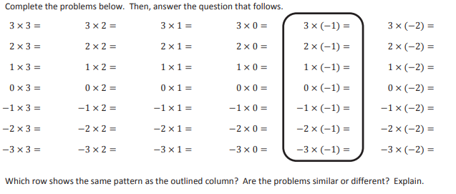

Module 2 Lesson 11 Homework

Module 2 Lesson 12 Homework

Complete the table below. Provide an answer for each integer division problem, and write a related equation using integer multiplication.

Integer Division Problem | Related Equation Using Integer Multiplication
-36$÷$(-9)
24$÷$(-8)
50$÷$10
42$÷$6

Module 2 Lesson 12 Homework

Complete the table below. Provide an answer for each integer division problem, and write a related equation using integer multiplication.

Integer Division Problem | Related Equation Using Integer Multiplication
-36$÷$(-9)
24$÷$(-8)
50$÷$10
42$÷$6

Module 2 Lesson 13 Homework

- Convert to Fractions

- 0.4
- 0.16
- 0.625
- 0.08
- 0.012

- Convert each fraction or mixed number to a decimal

- $\frac{4}{5}$

- $\frac{3}{40}$

- $\frac{8}{200}$

- $3\frac{5}{16}$

Module 2 Lesson 13 Homework
- Convert to Fractions

0.4
0.16
0.625
0.08
0.012

- Convert each fraction or mixed number to a decimal

4/5

3/40

8/200

3$\frac{5}{16}$

Module 2 Lesson 14 Homework

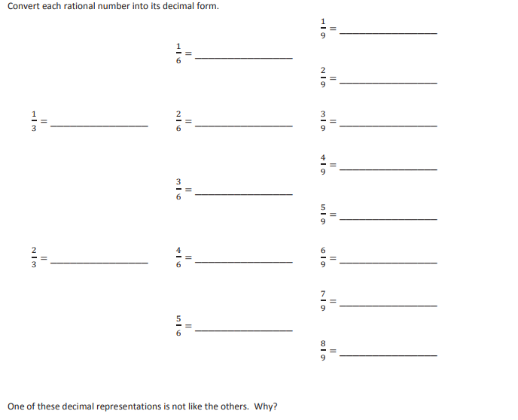

Module 2 Lesson 15 Homework

- At lunch time, Benjamin often borrows money from his friends to buy snacks in the school cafeteria. Benjamin borrowed $0.75 from his friend Clyde five days last week to buy ice cream bars. Represent the amount Benjamin borrowed as the product of two rational numbers; then, determine how much Benjamin owed his friend last week.

- Monica regularly records her favorite television show. Each episode of the show requires 3.5% of the total capacity of her video recorder. Her recorder currently has 62% of its total memory free. If Monica records all five episodes this week, how much space will be left on her video recorder?

Module 2 Lesson 15 Homework

- At lunch time, Benjamin often borrows money from his friends to buy snacks in the school cafeteria. Benjamin borrowed $0.75 from his friend Clyde five days last week to buy ice cream bars. Represent the amount Benjamin borrowed as the product of two rational numbers; then, determine how much Benjamin owed his friend last week.

- Monica regularly records her favorite television show. Each episode of the show requires 3.5% of the total capacity of her video recorder. Her recorder currently has 62% of its total memory free. If Monica records all five episodes this week, how much space will be left on her video recorder?

Module 2 Lesson 16 Homework
- $(2\frac{1}{4})×(-8)$

- $\frac{2}{3}\left(-7\right)+\frac{2}{3}(-5)$

- 0.38$×3÷(-\frac{2}{20})×5÷(-8)$

Module 2 Lesson 16 Homework
- $(2\frac{1}{4})×(-8)$

- $\frac{2}{3}\left(-7\right)+\frac{2}{3}(-5)$

- 0.38$×3÷(-\frac{2}{20})×5÷(-8)$

Module 2 Lesson 17 Homework
1.A taxi cab in Myrtle Beach charges $2 per mile and $1 for every person. If a taxi cab ride for two people costs $12,how far did the taxi cab travel?

2. Heather works as a waitress at her family’s restaurant. She works 2 hours every morning during the breakfast shift and returns to work each evening for the dinner shift. In the last four days, she worked 28 hours. If Heather works the same number of hours every evening, how many hours did she work during each dinner shift?

3. Jillian exercises 5 times a week. She runs 3 miles each morning and bikes in the evening. If she exercises a total of30 miles for the week, how many miles does she bike each evening?

Module 2 Lesson 17 Homework
1. A taxi cab in Myrtle Beach charges $2 per mile and $1 for every person. If a taxi cab ride for two people costs $12, how far did the taxi cab travel?

2. Heather works as a waitress at her family’s restaurant. She works 2 hours every morning during the breakfast shift and returns to work each evening for the dinner shift. In the last four days, she worked 28 hours. If Heather works the same number of hours every evening, how many hours did she work during each dinner shift?

3. Jillian exercises 5 times a week. She runs 3 miles each morning and bikes in the evening. If she exercises a total of30 miles for the week, how many miles does she bike each evening?
Module 2 Lesson 18 Homework
- Eric’s father works two part time jobs, one is in the morning and one in the afternoon, and works a total of 40 hours each 5-day workweek. If his schedule is the same each day, and he works 3 hours each morning, how many hours does Eric’s father work each afternoon?

- Write three other expressions that are equivalent to 8x-12

Module 2 Lesson 18 Homework
- Eric’s father works two part time jobs, one is in the morning and one in the afternoon, and works a total of 40 hours each 5-day workweek. If his schedule is the same each day, and he works 3 hours each morning, how many hours does Eric’s father work each afternoon?

- Write three other expressions that are equivalent to 8x-12

Module 2 Lesson 19 Homework
1. A family of 12 went to the local Italian restaurant for dinner. Every family member ordered a drink and meal, 3 ordered an appetizer, and 6 people ordered cake for dessert.
a. Write an expression that can be used to figure out the cost of the bill. Include the definitions for the variables the server used.

b. The waitress wrote on her ordering pad the following expression: 3(4𝑑𝑑 + 4𝑚𝑚 + 𝑎𝑎 + 2𝑐𝑐). Was she correct? Explain why or why not.

c. What is the cost of the bill if a drink costs $3, a meal costs $20, an appetizer costs $5.50, and a slice of cake costs $3.75?

2. Sally designs web pages for customers. She charges $135.50 per web page; however, she must pay a monthly rental fee of $650 for her office. Write an expression to determine her take-home pay after expenses. If Sally designed 5 web pages last month, what was her take-home pay after expenses?

Module 2 Lesson 19 Homework
1. A family of 12 went to the local Italian restaurant for dinner. Every family member ordered a drink and meal, 3 ordered an appetizer, and 6 people ordered cake for dessert.
a. Write an expression that can be used to figure out the cost of the bill. Include the definitions for the variables the server used.

b. The waitress wrote on her ordering pad the following expression: 3(4𝑑𝑑 + 4𝑚𝑚 + 𝑎𝑎 + 2𝑐𝑐). Was she correct? Explain why or why not.

c. What is the cost of the bill if a drink costs $3, a meal costs $20, an appetizer costs $5.50, and a slice of cake costs $3.75?

2. Sally designs web pages for customers. She charges $135.50 per web page; however, she must pay a monthly rental fee of $650 for her office. Write an expression to determine her take-home pay after expenses. If Sally designed 5 web pages last month, what was her take-home pay after expenses?

Module 2 Lesson 20 Homework
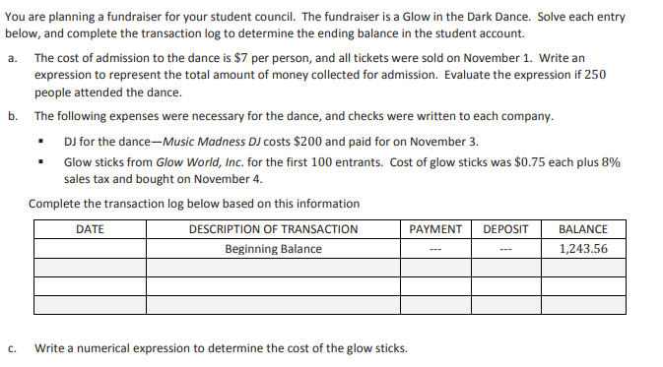

Module 2 Lesson 20 Homework
Module 2 Lesson 21 Homework

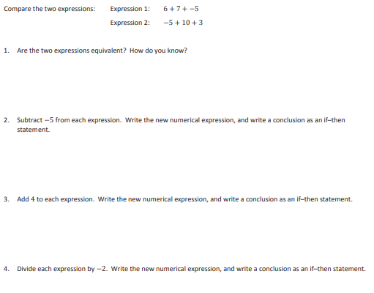

Module 2 Lesson 22 Homework
Solve
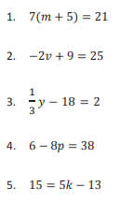
Module 2 Lesson 22 Homework
Solve

Module 2 Lesson 23 Homework
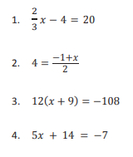
5. Bob’s monthly phone bill is made up of a $10 fee plus $0.05 per minute. Bob’s phone bill for July was $22. Write an equation to model the situation using 𝑚𝑚 to represent the number of minutes. Solve the equation to determine the number of phone minutes Bob used in July.

Module 2 Lesson 23 Homework
5. Bob’s monthly phone bill is made up of a $10 fee plus $0.05 per minute. Bob’s phone bill for July was $22. Write an equation to model the situation using 𝑚𝑚 to represent the number of minutes. Solve the equation to determine the number of phone minutes Bob used in July.

